RESUME

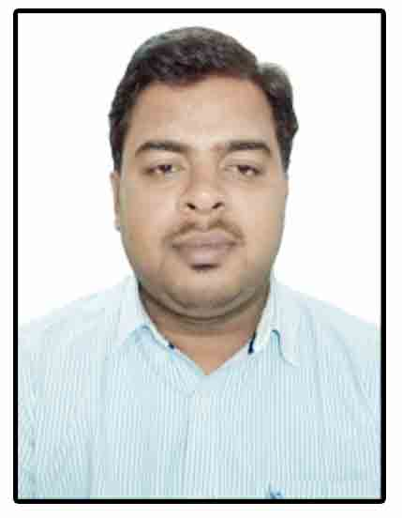  SAURABH YADAV  Email:saurabhyadav063@gmail.com  Mobile No:9457192305 (India),  971521659059 (UAE)  Personal Information:  Father’s Name: Beerpal Singh Yadav  Date of Birth: 13-04-1992  Sex: Male  Nationality: Indian  Marital Status: Married  Languages Known: English & Hindi  Email: saurabhyadav063@gmail.com  Mobile No: 9457192305 (India),  971521659059 (UAE)  Address: 122/3, Yadav Nagar,  Kusmara,  Distt- Mainpuri- Uttar Pradesh  Pin- 205304  Permanent Address:  122/3, Yadav Nagar,  Kusmara,  Distt- Mainpuri- Uttar Pradesh  Pin- 205304 | Career Objective  Intends to build a career with a leading organization where I can add value to company's image, brand and culture. I would like to unearth my full potential to contribute maximum to my job and organization. More than willing to work as a team player in challenging, open and creative environment.  Experience  B.Tech in civil engineering with 5Years experience in solar projects.  Good knowledge of construction of all types of foundation in solar projects as piling, anchoring, J-Bolt foundation, Ramming etc. and having experience to construct building as MCR & LCR, switchyard, Transmission line, Road, culvert, Drainage, Cable Trenches etc. Also having experience in module mounting structure erection and DC work in solar projects.  Presently working with Sterling and Wilson Middle East Electro Mechanical L.L.C as aSr. Engineer- Civil (Solar projects).  Last worked with Vikram Solar Limited as a  Sr. Engineer- Civil (Solar projects).  Previously workedWith Jakson Engineers Limited As a  Sr. Engineer- Civil(Solar Projects).  Previously workedWith GangesInternationale Pvt. Ltd. As a  Project Coordinator- Civil(Solar Projects)  Projects-  Presently working in 1177MWp solar project Sweihan- Abu Dhabi, UAE Client-Abu- Dhabi water and electricity authority, Jinko SolarRole- Sr. Engineer- Construction  Completed 10 MW solar project Jabalpur – MP,Client- Bharat Electronics Limited and Vehicle factory Jabalpur (Ministry of Defence)  Role- Civil Incharge  Completed 10 MW solar project Itarsi – MP, Client-Bharat Electronics Limited and Ordnance factory Itarsi (Ministry of Defence)  Role- Civil Incharge  Completed 20 MW solar project Davangere- Karnataka Client- Jindal aluminium Limited.  Role- Civil Incharge  Completed 50 MW solar project Kasargod-Kerala PMC- SECI (Solar Energy Corporation of India Limited) and Client-IREDA (Indian Renewable Energy Development Agency ).  Role- Civil Incharge  Completed25 MW solar project Mansa Punjab Client- ACME cleantech solution Pvt Ltd.  Role- Site Incharge  Completed 3.6 MW solar project sivagangaiTamilnaduClient- SRL Green & Clean Power Pvt. Ltd.  Role- Site Incharge  Completed 21 MW solar projectAbohar, Punjab Client-solaire direct energy indiapvt ltd.  Role- Civil Incharge  Completed 15 MW solar project singrauli, Madhya Pradesh Client-BHEL and NTPC.  Role- Quality Engineer  Completed 1 MW solar projecttukuguda, Hyderabad, Andhra-Pradesh Client-Tata Power Solar System pvt Ltd.  Role- Site Engineer  Completed 25 MW solar projectRajgarh, Madhya Pradesh Client-Acme cleantech solution pvt Ltd.  Role- Site Engineer  Designation: Sr. Engineer- Civil (Solar Projects).  Keyskills:  - Good knowledge of MS Office, MS excel, Outlook, Auto cad etc.  - Abel to project planning and execution of work according to drawing and design.  - Co-ordination with client and sub-contractors.  - Work as a technical advisor to subcontractors, operatives and crafts people with respect to the construction site.  - Check the drawings, plans, and other qualities to get an accurate calculation.  - Ensure that the quality of materials used is according to the expectations. Able to oversee the requisition and selection of the materials.  - Monitor the contract documents such as managing, monitoring and interpreting the design.  - Supervise the labour force and sub contractors on day to day basis.  - Maintain a quality control on the site.  - Able to resolve unexpected technical problems that may arise in the site.  - Good leadership and managing skills.  Educational Qualification  - B.TECH (CIVIL ENGINEERING)  INDUS INSTITUTE OF TECHNOLOGY AND MANAGE MENT KANPUR  (GBTU CODE- 350)  Secured – 67.28 %  (UTTAR PRADESH TECHNICAL UNIVERSITY, LUCKNOW ( 2009-2013)  - Intermediate  Govt. Inter College Agra  Secured – 60.00 %  (U.P. BOARD-2009)  - High School  Govt. Inter College Agra  Secured – 67.00 %  (U.P. BOARD -2006).  Summer Training  - PWD-2 AGRA IN BRIDGE CONSTRUCTION FOR SIX WEEKS.  Subject Interest  - Structure Analysis, Transportation, Building Material And Construction, Tunnel engineering, Mathematics, Environmental engineering.  Personal Skills  - Excellent communication and inter personal team skills.  - Strong conceptual and analytical skills with adaptability, sincerity, and punctuality as the strongest beliefs.  - Processing ability to quickly grasp the latest technologies and self confident enough to provide leadership and direction.  - Strong leadership skills.  Hobbies  Travelling, Playing table tennis, chess, Reading newspaper.  Achievements  - In Vikram solar Limited, I have joined as a Sr engineer- Civil but worked as a Construction Incharge in all projects after management decision.  - When I was working in Jakson engineers Limited, I was joined at the post of Sr Engineer- Civil, But at site our management given me the responsibility of all construction work and decided to make a Team leader- Civil after observing my interest of work and technical knowledge.  - When I was working in Ganges InternationalePvt Ltd, Management selected me as a Site inchargewith in 2 years exp and given me particular site responsibility at Madurai- Tamilnadu while I was working as a site engineer in the organization. This was big achievement for me and I played well and completed the project on time.  - Selected as the Head of the discipline committee in Indus Institute Of Technology And Management Kanpur.  - Got participitate in “BHARTIYA SANSKRATI GYAN PARIKSHA” Shantikunj-Haridwar.  Declaration  I hereby declare that all information furnished above is true and complete to the best of my knowledge.  Date : (SAURABH YADAV)  Place:

